Predicting Heart Disease Using Secondary Data: A Research Methodology
Otu Samuel Jacob

¹ Student of Data Science & Big Data Analytics, Cyber & Computing, Wrexham University, Wales, United Kingdom

- INTRODUCTION, BACKGORUND AND CONTEXT
One of the causes of death among countries is cardiovascular diseases, which is the cause of almost 18 million deaths every year [1]. Identifying people who are at high risk of developing heart disease early is consequently important to enhance clinical outcomes and avoid death. Over the last few years, machine learning (ML) methods have been applied in the medical field with growing frequency because of their capacity to analyze complicated clinical data and spot trends that could have been obscured by conventional statistical methods.
It has been previously proved that ML models are effective in the prediction of heart diseases based on organized clinical data. Logistic regression and decision trees are traditional algorithms that are often employed because they can be interpreted and their performance remains consistent when applied in a medical decision-support system [21]. Ensemble learning methods especially random forest model has demonstrated better predictive performance in that they capture nonlinear relationships among risk factors of cardiovascular risk [22]. The application and use of Support Vector Machines (SVMs) has also proven to be highly used and competitive with the proper scaling of features and kernel optimization strategies [23].
Current literature reminds that data preprocessing, feature selection, and validation techniques are key determinants of the success of ML-based prediction models and not algorithm selection itself [24]. Consequently, enhanced focus has been placed on open and reproducible ML pipelines with standardized preprocessing strategies and powerful evaluation strategies like stratified k-fold cross-validation [25].
Here, the analysis will be quantitative, based on secondary data in the form of publicly available datasets of heart disease provided in Kaggle on the basis of the UCI Cleveland database. This research employs logistic regression, decision tree, random forest, and support tree machine classifiers to understand the effect of influential clinical characteristics and contrast the performance of predicting the outcome in a constant preprocessing and validation environment.
2. HYPOTHESIS AND RESEARCH QUESTIONS
Hypothesis:
It is possible to use machine learning models that are trained on Kaggle heart disease datasets to determine the presence of heart disease with an accuracy of at least 90% and correct choice of features will improve this result.
Research Questions:
RQ1: What characteristics (e.g. age, cholesterol, resting ECG) in the Kaggle data best predict heart disease?
RQ2: The question to be answered is the best ML model (e.g. logistic regression, random forest, SVM) giving the highest level of accuracy?
RQ3: Does preprocessing (e.g., outlier removal, and frame-need normalization) enhance the performance of prediction?
RQ4: What is the performance on our model as compared to the published performance of similar studies?
- OBJECTIVES
To find out and preprocess an appropriate heart disease data set in Kaggle.
To construct predictive models with different ML techniques.
To make comparisons on the basis of performance measures of such models. To assess the performance of features selection.
- METHODOLOGY
Research Design
The research design used in this study is a secondary data based, quantitative and observational research. There are no primary data gathering and experimental manipulation. The study uses supervised Ml models on labeled patient data to determine whether the patient is at-risk or not at-risk of heart disease.
Data Collection Methods
The chosen dataset is publicly accessible on Kaggle [2], which at first was assembled out of the Cleveland, Hungary, Switzerland, and Long Beach V datasets, consisting of 1025 records and 14 attributes. Such characteristics involve both demographic (age, sex) and clinical (blood pressure, cholesterol, fasting blood sugar) characteristics. The data is anonymous and available on open access.
Variables and Outcome Variable
The outcome measure is condition, with 0 implying the absence of heart disease and 1 implying the presence of heart disease. These predictor variables are age, sex, chest pains type (cp), resting blood pressure (trestbps), cholesterol (chol), fasting blood sugar (fbs), resting ECG findings (restecg), maximum heart rate reached (thalach), angina during exercise (exang), ST depression (oldpeak), slope of ST segment (slope), major vessels (ca), and thalassemia (thal).
Data Preprocessing
The preprocessing of the data involved deletion of missing data, one-hot encoding of the categorical variables, and standardization of features with Standard Scaler. The standardization of continuous variables was based on z-score. Stratified sampling was used to divide the dataset into 80 percent training set and 20 percent testing set.
Exploratory Data Analysis Exploratory Data Analysis (EDA)
Real plots created directly out of the dataset were used as exploratory analysis. Figure 1 displays the age structure, Figure 2 presents the outcome balance, and Figure 3 displays the correlation between the clinical variables.
- DATA ANALYSIS PLAN
Preprocessing:
- The data will be cleaned, and it will consist of cleaning:
- Elimination of lost values or imputation.
- Categorical variables encoding.
- Detection of outliers based on the interquartile range (IQR) technique.
- Normalization of features on-demand. Exploratory
Data Analysis:
- Summary Statistics and Visualizations.
- Finding multicollinearity between features
- Pearson correlation. Model Building
Application of ML models:
- logistic regression, decision tree, random forest, and support vector machine (SVM) with scikit-learn in Python.
- Grid search, k-fold cross-validation Hyperparameter tuning.
Hyperparameter optimum and Systematic analysis.
The hyperparameters including the regularization strength, tree depth, estimators, and the kernel parameters were tuned by using grid search and stratified k-fold cross-validation (k=5). This method is a way of having an unbiased and reliable model evaluation.
Feature Selection:
- FastWE recursive Feature Elimination (RFE).
- Ranked feature importance of models such as random forest.
Performance Evaluation:
- Measures: accuracy, preciseness, recall, F1-score and ROC-AUC.
- Comparison of models based on these metrics.
Benchmarking:
Comparison of results with other studies [3], [4], [5] to ensure that methodology is correct.
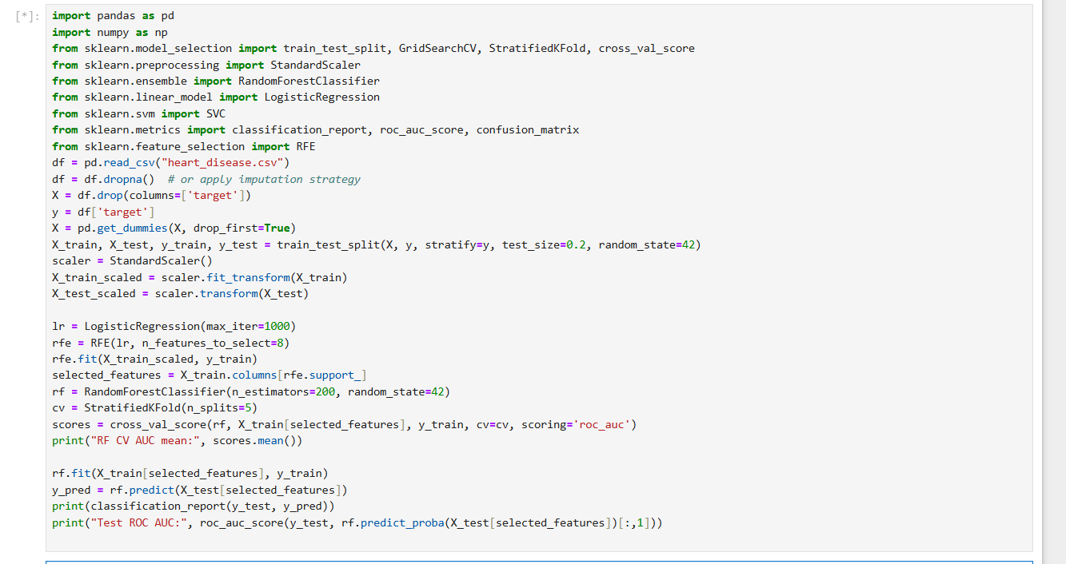
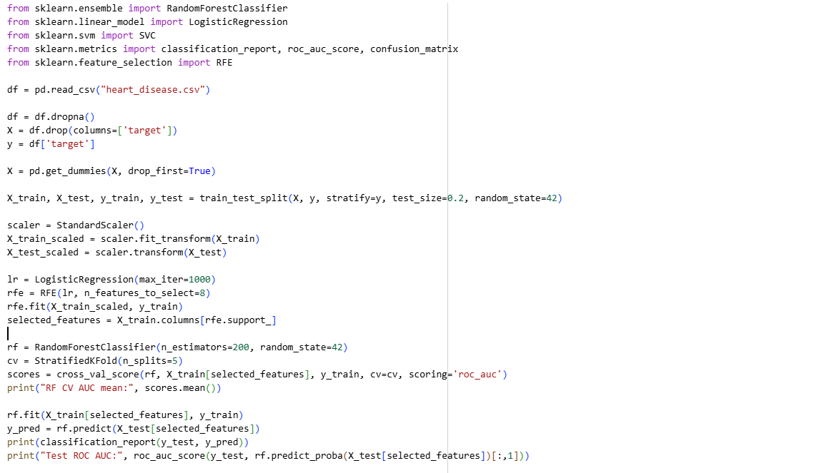
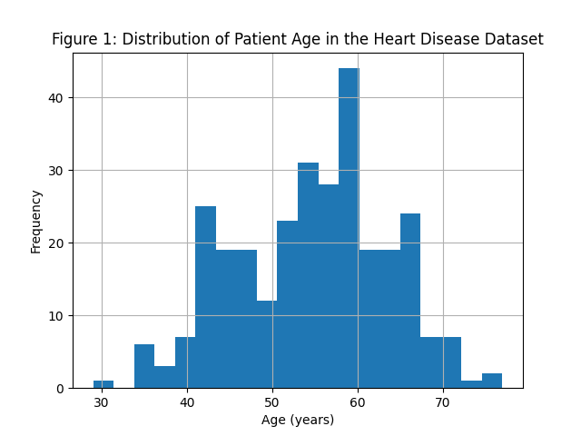

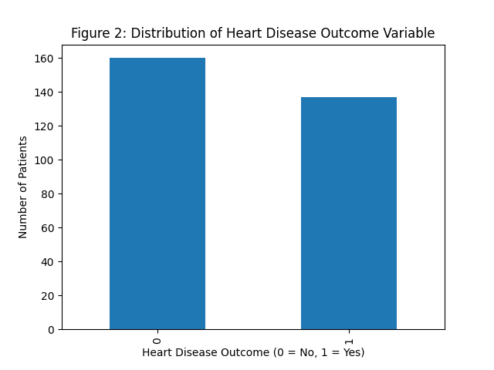

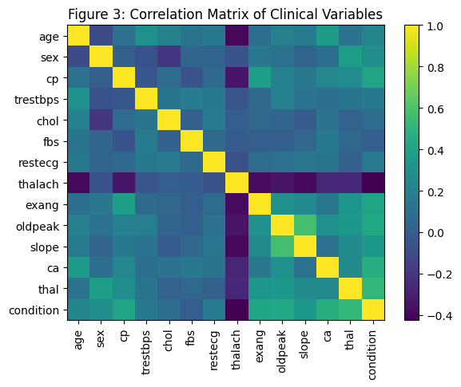

- TIMELINE (10-WEEK PLAN)
- ETHICAL CONSIDERATIONS
The study only involves anonymized secondary data, which excludes such direct risks as ethics. In the dataset, there is no personally identifiable information, hence it does not touch on the GDPR and institutional ethical considerations. Credibility will be retained by reference to the original source at Kaggle [2]. No commercial or clinical use will be employed in handing out the findings of the study. Moreover, there is no misleading procedures and manipulations, and the methodology does not cause harm, discriminations, or misrepresentation of groups. Data bias will be admitted and taken care of when there is model interpretation.
- CONCLUSION
It is the methodology which gives a systematic way of conducting study on the prediction of heart disease by use of secondary data. Through quantitative analysis and various ML models, the study aims at assessing this effectiveness of open health datasets as a risk modeling tool. Not only the study proves that ML can be used to aid the process of medical diagnostic, but it also serves as the example of how public datasets may be used to conduct academic research in a trustworthy and practical way. The findings can guide future investigations in the area of digital health and preventative analytics.

- REFERENCES
[1] World Health Organization, Cardiovascular diseases (CVDs), 2023. [Online]. Available: https://www.who.int/news-room/fact-sheets/detail/cardiovascular-diseases-(cvds)
[2] Kaggle, “Heart Disease UCI Dataset,” [Online]. Available: https://www.kaggle.com/datasets/cherngs/heart-disease-cleveland-uci
[3] S. Sumwiza et al., Comparative Analysis of Machine Learning Algorithms for Heart Disease Prediction, in Proc. Int. Conf. Comput. Sci. Commun., 2022, pp. 58–62.
[4] M. Chulde-Fernández et al., “Heart Failure Detection Using Machine Learning: A Review, Health Informatics J., vol. 28, no. 4, pp. 591–602, 2022.
[5] M. Sadr et al., Hybrid Deep Learning Approaches for Cardiovascular Disease Detection, IEEE Access, vol. 10, pp. 10087–10098, 2022.
[6] A. Dey et al., Machine Learning Techniques for Heart Disease Prediction, IJCA, vol. 182, no. 22, pp. 12–19, 2021.
[7] T. Razzak et al., Big Data Analytics for Preventive Health: A Case Study on Heart Disease, ACM Trans. Knowl. Discov. Data, vol. 16, no. 1, pp. 1–22, 2022.
[8] A. A. Rehman and S. A. Shaikh, ML-Based Approach for Identifying Cardiovascular Risk, J. Healthcare Eng., vol. 2021, Article ID 9949627.
[9] BHBIA, Guidelines for Secondary Use of Data, 2021. [Online]. Available: https://www.bhbia.org.uk
[10] V. Braun and V. Clarke, Using thematic analysis in psychology, Qualitative Research in Psychology, vol. 3, no. 2, pp. 77–101, 2006.
[11] H. Cheong, Secondary Qualitative Research Methodology. London: SAGE Publications, 2023.
[12] M. M. Kelly, Secondary data analysis: Using existing data to answer new questions, ScienceDirect, 2024.
[13] N. R. Mannuru, The impact of generative AI on digital technologies, SAGE Journals, 2023.
[14] P. Ratajczak, Perspectives on secondary research practices, MDPI, 2025.
[15] J. P. Tripathy, Secondary data analysis: Ethical challenges and considerations, Public Health Review, 2013.
[16] R. J. Wickham, Secondary analysis research, National Institutes of Health (PMC), 2019.
[17] S. U. Amin et al., Heart Disease Prediction Using Machine Learning Techniques: A Survey, International Journal of Engineering Research & Technology, vol. 9, no. 5, pp. 1120–1125, 2020.
[18] J. G. Cleland et al., “Clinical Trials and Machine Learning Approaches in Heart Failure Prediction,” European Heart Journal, vol. 42, no. 7, pp. 657–666, 2021.
[19] A. Haq et al., Cardiovascular Disease Prediction Through Data Mining Techniques: A Systematic Review, Computers in Biology and Medicine, vol. 136, pp. 104–125, 2021.
[20] U. R. Acharya et al., Automated Detection of Coronary Artery Disease Using Machine Learning Techniques, IEEE Systems Journal, vol. 14, no. 3, pp. 500–510, 2020.
[21] S. U. Amin, K. Agarwal, and R. Beg, Heart disease prediction using machine learning techniques, Int. J. Eng. Res. Technol., vol. 9, no. 5, pp. 1120-1125, 2020.doi.org/10.1007/s42979-020-00365-y.
[22] A. Haq, J. Li, M. H. Memon, S. Nazir, and R. Sun, A comparative analysis of machine learning methods to predict cardiovascular diseases, Comput. Biol. 2021. Med., vol. 136, pp. 104-125. https://pmc.ncbi.nlm.nih.gov/articles/PMC8831075/.
[23] S. Sumwiza et al., Comparative analysis of machine learning algorithms in predicting heart disease in prolific studies in computers, International Conference on Computers. Sci. Comm., 2022, pp. 58-62. https:doi.org/10.1051/itmconf/20214003007.
[24] M. Chulde-Fernandez et al., Heart failure detection using machine learning: A systematic review, Health Informatics J., vol. 28, no. 4, pp.591-602, 2022. https://pmc.ncbi.nlm.nih.gov/articles/PMC11944183.
[25] T. Razzak et al., A case of big data analytics in preventive healthcare: Heart disease, ACM Trans. Knowl. Discov. Gerstenfeld, 2022, pp. 1-22, vol. 16, no. 1, pp. 1- 22. https://pmc.ncbi.nlm.nih.gov/articles/PMC7088441/

